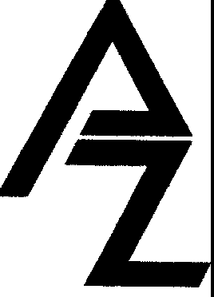

LAW OFFICES OF ARMEN ZADOURIAN
2606 Foothill Blvd. Ste#A La Crescenta, CA 91214
Phone: (818) 538-3303 Fax: (818) 538-3304
Luis@ZadourianLaw.com

June 1, 2025

State of CA-WCAB
6150 Van Nuys Blvd, #105
Van Nuys, CA 91401

RE: | MOISES SANCHEZ vs KENYON PLASTERING OF SOUTHERN CALIFORNIA, INC
 | DATE OF INJURY: | CT 03/30/2023 - 12/29/2024
 | WCAB CASE#: | ADJ21019138
 | CLAIM#: | 1E01E017567285

Dear Clerk of the Court:

Respectfully, Applicant on the above captioned matter through his attorney of record hereby requests a change of address on the official record. The applicant’s new mailing address is as follows:

MOISES SANCHEZ
216 W 28th St., Apt# 2
Los Angeles, CA 90007

A copy has been served by first class mail to the corresponding parties on the claim. Please do not hesitate to contact the undersigned should you have any questions, requests, or concerns.
We thank you in advance for your valuable time and attention. Respectfully,

___________________________
Alfredo Barillas for
Armen Zadourian, Esq.

Enclosure
Cc: See Attached Proof of Service

